Урок по английскому языку для 9 класса
6-12 апреля
Срок сдачи готовой работы: 12. 04.
Инструкция: задания выполнять в тетради АККУРАТНЫМ почерком, либо в учебнике, если для ответа предусмотрено место. Фото готовой работы (т.е. ВСЕ задания) высылать на эл. почту darya.elkina@mail.ru

Topic of the lesson “One world. Vocabulary”
шаг | материал | задание | Действия ученика
 | SB page 60  SB page 60 #1  SB page 61 #2  (W) page 56 #1  SB page 61 #3 | Before we start. Look at Module Objectives (цели этого раздела), read what material we are going to study. Got it? Fine!  5.1 Geographical features and Natural Disasters  - Choose 1 odd word in each line, give your reasons  - Match the paragraph titles 1-6 with definitions  - Fill in the gaps  - Read the text, correct the sentences afterwards | Read  Orally (do not write)  Do it on the book page.  Do it on the book page.
 | SB page 60-61 text  SB page 61 #5, (W) page 56#2  SB page 61 #8, (W) page 57#3  SB page 61 #10, (W)page57#4,5 | Vocabulary  - Words printed in RED. Wordstore 5A (in the end of your book)  - UNDERLINED words. Wordstore 5B  - HIGHLIGHTED words. Wordstore 5C | Write out the key words into your copy-book, translate. You may do the tasks in wordstore as well.
 | (W) page 57 #6 | Self check  - Learn the key words  - Do the task without any help (I trust you)  - See Appendix 1 , 2 (Приложения 1,2 ниже таблицы) | Memorize the key words  Do the tasks
 | SB page 62 #1,2  (W) page 58#4,5  SB page 121 5.2 | 5.2 Grammar. Articles  1) read to get the main idea. Read the rule and fill the gaps. If necessary watch videos  2) zero article (no article Ø )https://interneturok.ru/lesson/english/7-8-klassy/artikl/nulevoy-artikl  3) indefinite article (a/an) https://interneturok.ru/lesson/english/7-8-klassy/artikl/nulevoy-artikl  4) definite article(the) https://interneturok.ru/lesson/english/7-8-klassy/artikl/opredelennyy-artikl  5) some practice here https://www.liveworksheets.com/worksheets/en/English_as_a_Second_Language_(ESL)/Definite_and_Indefinite_Articles/Articles_-The_Body-_by_Stephen_King_ar3002sp  https://www.liveworksheets.com/worksheets/en/English_as_a_Second_Language_(ESL)/Articles/Articles_dy50522if  https://create.kahoot.it/details/articles-a-an-the/aadf3ae7-d3cc-4c56-bf9f-3ad35871a69f  or here  - See Appendix3  - See Appendix 4 | Complete the task. Watch videos (if necessary).  Follow the link. Practice.  Complete the table  Do the test
 | - | Speaking  Be ready to speak about the territories of Russia that are in danger of natural disasters (note: make a plan) | Find info about natural disasters and tell about them in 10-12 sentences

My results (no problem) , :/ (ok), (aah…what?)
Я знаю | Key words: natural disasters, geographical features
Я знаю | The difference between articles
Я умею | Use the articles in tests and my speech
Я не понял

APPENDIX 1
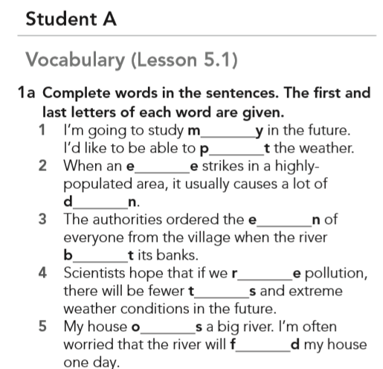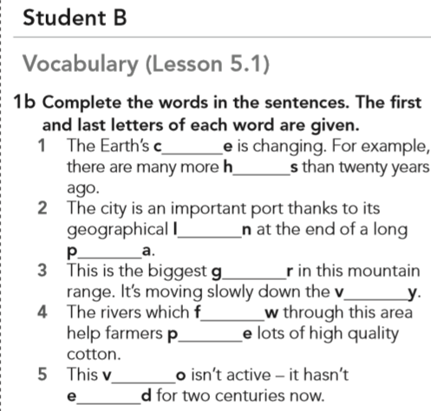

APPENDIX 2
When you do the Student A task, look at the pictures in your card. BUT! Read the definition in Student B’s card

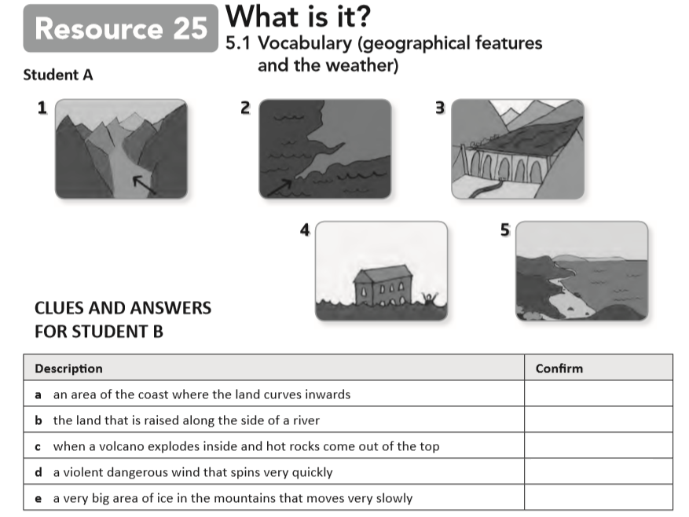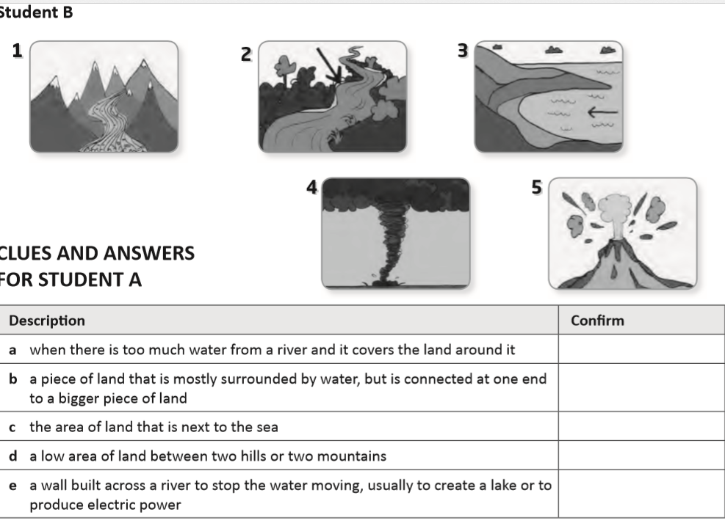

APPENDIX 3

Complete the table “Use of articles”
a/an | the | Ø
- Исчисляемые сущ в ед.ч.  - Впервые упомянутый предмет | - С исчисляемыми и неисчисляемыми сущ в ед или мн.ч. | - Города  - Континенты

APPENDIX 4
