Задания по английскому языку для 8а в период с 16.11 по 20.11. (группа Ю.С.)
Дата | Тема | На уроке | Д.з.
16.11 | Образование: повторение лексики | Работа с дополнительными материалами (Приложение 1, 2 ) | Сделать задания приложения 1 и 2 на оценку!!!
16.11 | Устойчивые выражения: Word store 5C | Уч. Word store 5C стр.11 (выписать все фразы в тетрадь с переводом, всего 20 фраз!)  Стр.61 упр. 12 | Раб.тетрадь стр. 56-57 (все задания до конца)  Кроссворд – на оценку!!!
19.11 | Повторение раздела 1.1. | Закрепление лексики | Приложение 3 – на оценку !!!
20.11 | Работа с экзаменационной темой Comfortable Living | Приложение 4 (распечатать/переписать, разобрать) | Тема!!!
20.11. | Первый тип условных предложений: теория | Уч.стр.62 упр.1,3, 4  + схема (Приложение 5, переписать в тетрадь) | Раб.тетрадь стр.58 упр.1,2 + правила учить

Внимание: на проверку присылаем задания из Приложений 1, 2, 3 и кроссворд. Странички можно распечатать, сделать задания, сфотографировать и отправить. Можно переписать в тетрадь и сфотографировать. Фото присылать на электронную почту, обязательно написать имя и фамилию!
Адрес моей электронной почты yu.shershneva@yandex.ru, домашние задания принимаются до воскресенья 22 ноября! Вопросы тоже можно задавать по электронной почте.
Данные материалы будут размещены:
- в вашей группе в вайбере (через Ольгу Владимировну);
- на сайте гимназии;
- в электронном журнале к каждому уроку будет прикреплен этот файл.
За эту неделю вы получите 3 оценки!
С пятницы уроки будут проводиться в зуме, СК в зуме (вторник в 8.00!!!)
До встречи! See you!

Приложение 1
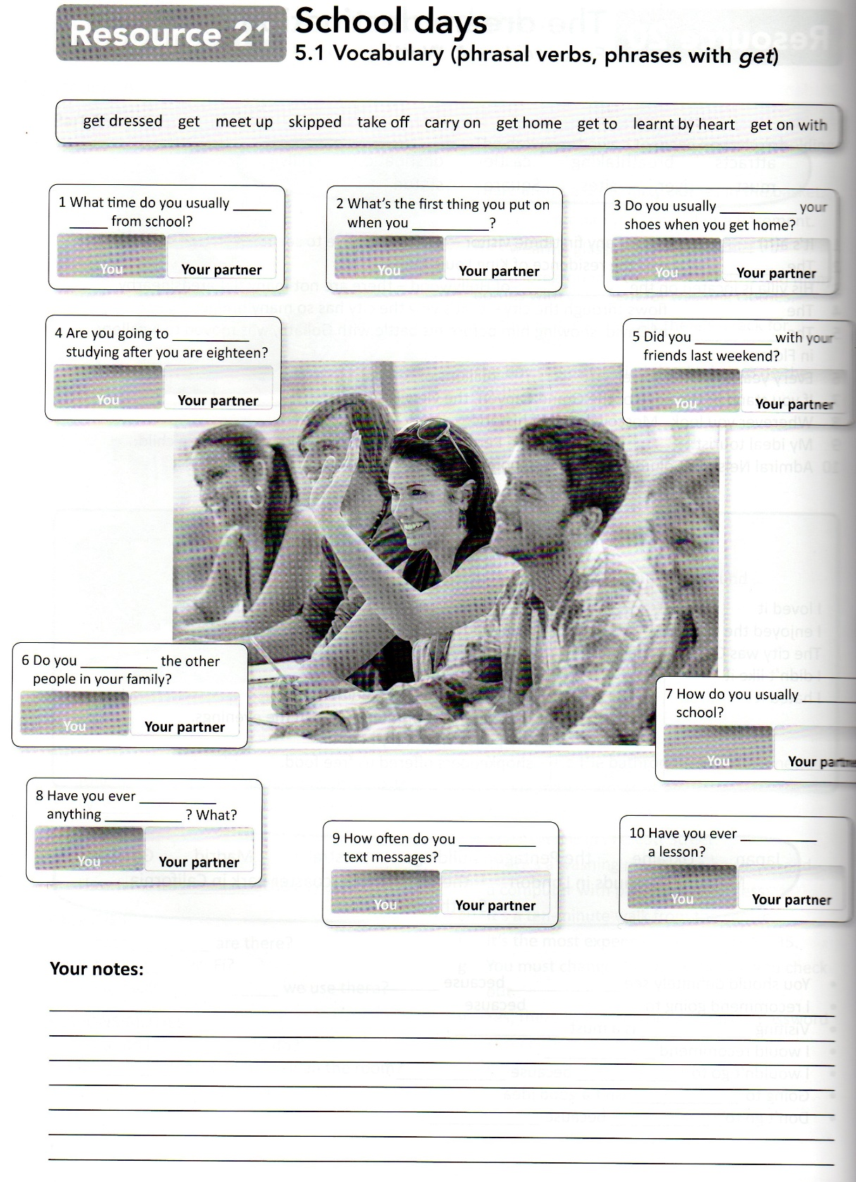
Написать 10 ответов о себе

Приложение 2
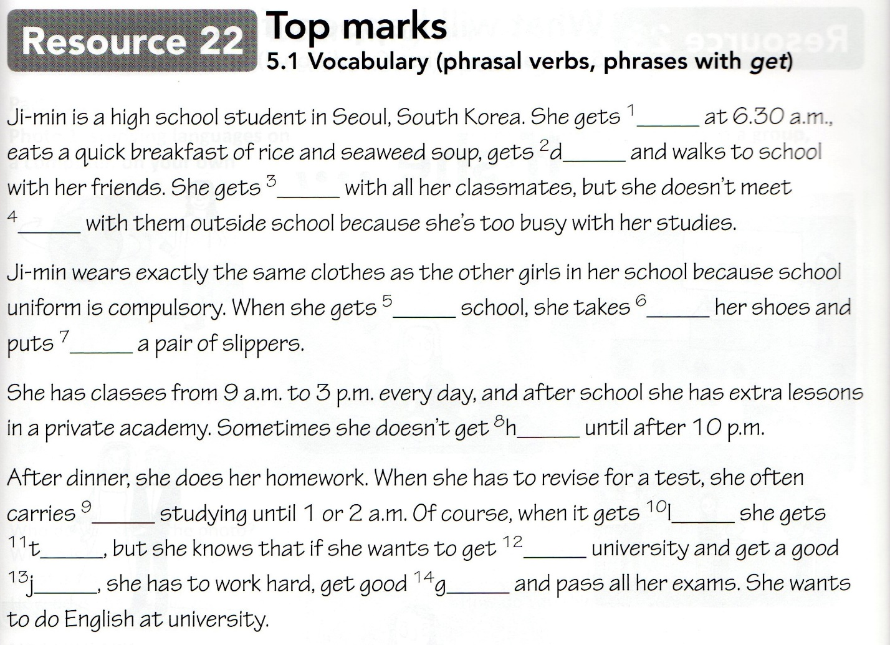

Crossword Education
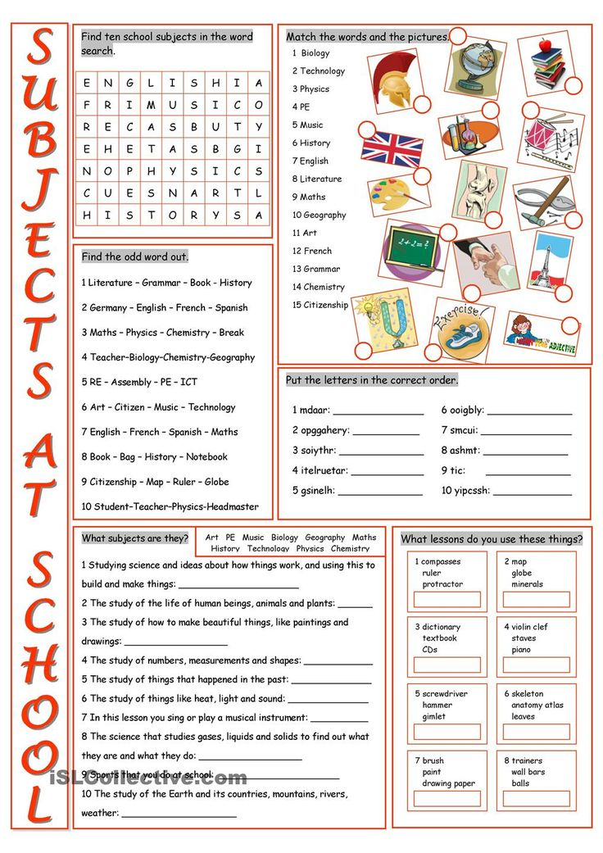

Приложение 3
Education Phrasal verbs Phrases with get
Word families
1 Complete the sentences with suitable words. The first letter of each word is given.
0 The d i s c i p l i n e at my school is very strict, so it’s important not to break the rules.
1 I wouldn’t like to have a u _ _ _ _ _ _ and have to wear the same clothes at school every day.
2 You have to study Maths, English and IT at my school – they’re c _ _ _ _ _ _ _ _ _ subjects.
3 What lesson is next on our t _ _ _ _ _ _ _ _ for this morning?
4 Our teacher has asked us to m _ _ _ _ _ _ _ a long poem for homework, but I know I won’t remember it all!
/4

2 Match 1–4 with a–g to make sentences. There are two extra options.
0 Tom is taking a d
1 Jack’s happy; he’s passed
2 Maria is going to drop
3 I want to leave
4 Charlie decided to skip

a the school gate.
b music next term.
c the schedule.
d break from studying.
e school and get a job.
f yesterday’s lessons.
g a difficult exam.
/4

3 Complete the sentences with the words and phrases in the box. There are two extra options.
a place better dark nervous ready rid up
0 Don is hoping to get a place at university to study Medicine.
1 Fiona was ill last week, but she’s slowly getting .
2 I always get before I take an exam.
3 It’s getting and I’ve got no lights on my bike.
4 This laptop’s old and faulty, I should get of it.

Приложение 4
Comfortable Living
- People’s homes have changed enormously.
- They have certainly become much more comfortable nowadays with all modern conveniences.
- Very few people had these in their homes a hundred years ago.
- Now people can choose a place for living according to their preferences, demands and finances.
- Today it’s getting more and more popular to live on a housing estate – modern similar houses in the same area.
- A lot of people prefer to live in their own houses: they choose cottages in the countryside or a village.
- Nowadays many people are considered to be environmentally-friendly so they build eco-houses or live in bungalows.
- Big cities have very poor areas around them which are called slums, and a lot of people live there in very poor conditions.
- Modern building have all conditions necessary for living: electricity, central heating, running water, gas for cooking.
- But many people choose natural environment: houses made of stone and wood, with solar panels on roofs, drinking water from a nearby spring and a compost toilet. All these help to keep the planet green but people’s life becomes harder.
- People try to make their homes cosier and nicer.
- They decorate houses and flats with different items: curtains, carpets, posters, photos and pictures.
- Modern apartments are usually spacious, with equipped kitchens, large sitting rooms and balconies.
- My favourite place in our flat/house is ……..
- I like spending time there because ………….
- Probably I’d change it a bit and add some ……
- In general, I think nowadays people live in quite comfortable conditions.

Приложение 5

