Урок дистанционного обучения в 8 «Б» классе
21 апреля 2020

Pictures (Warmer)

- Look at the following paintings. Which of them appeals to you more than the others? Why? What emotions do you have looking at it? What ideas occur to you?

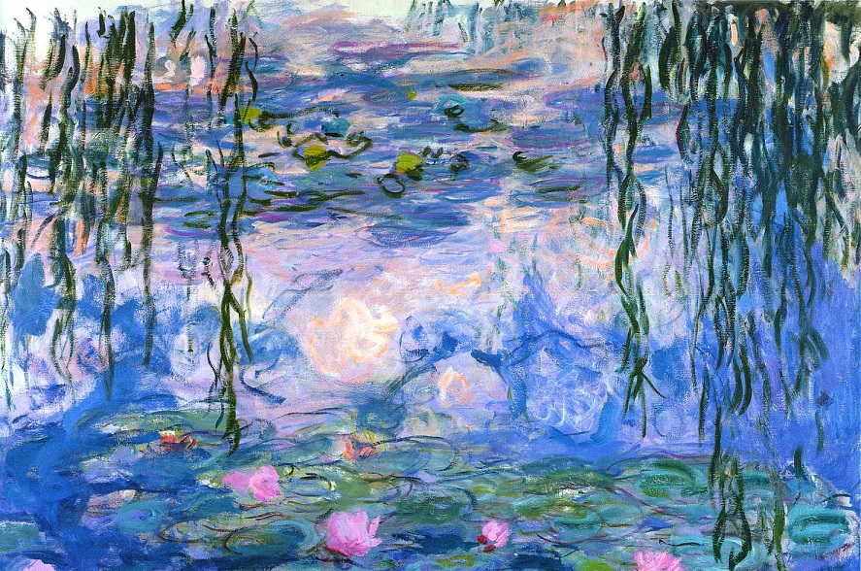 | 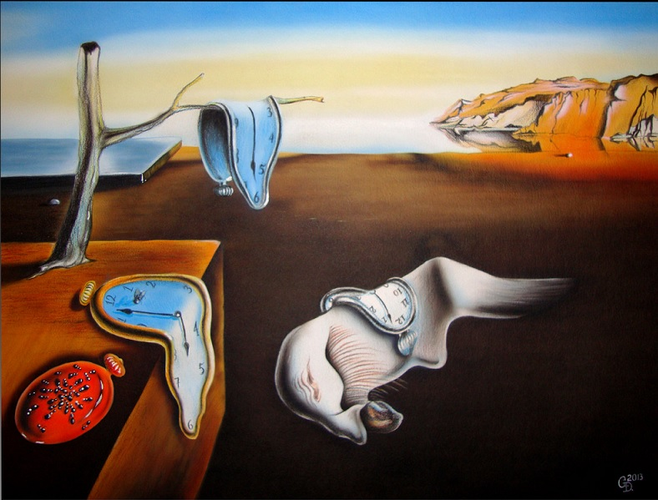
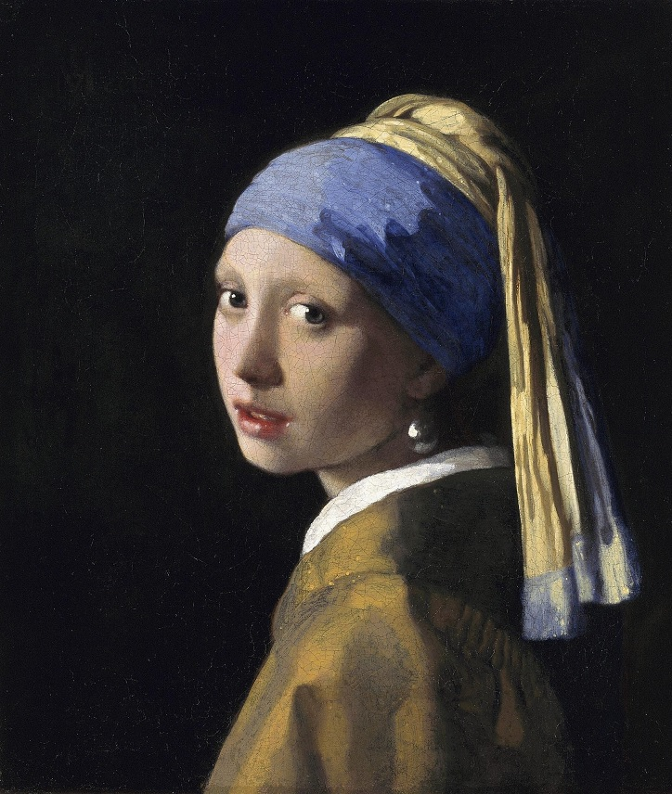 | 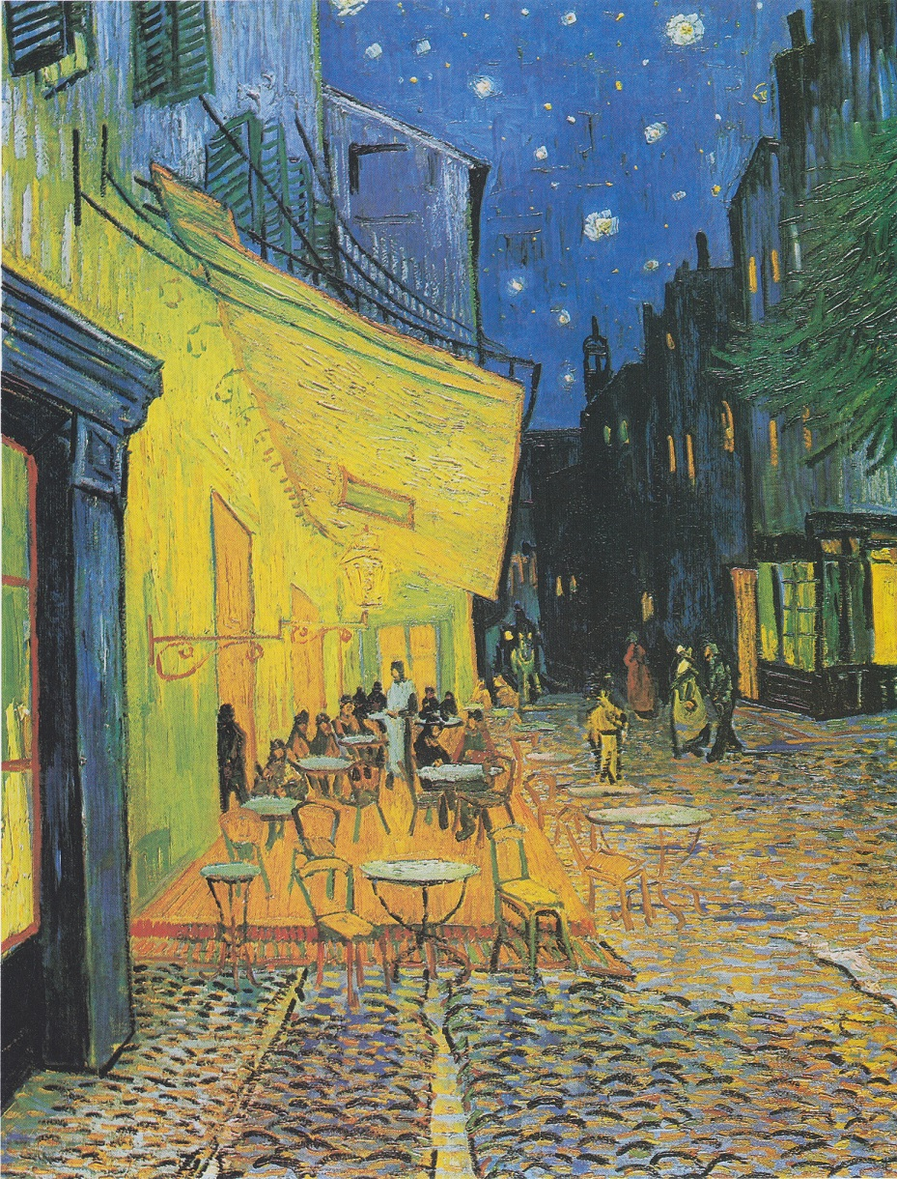
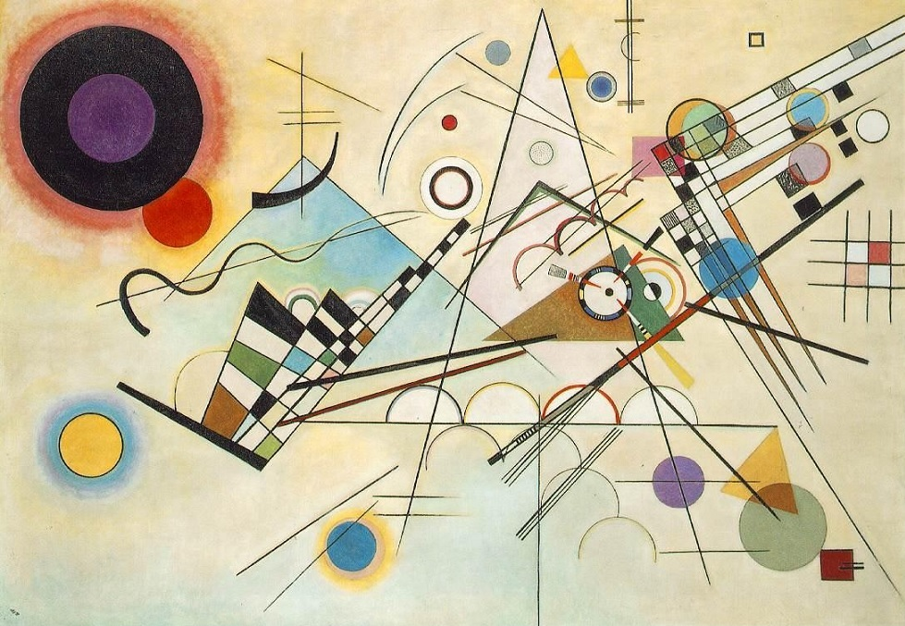 | 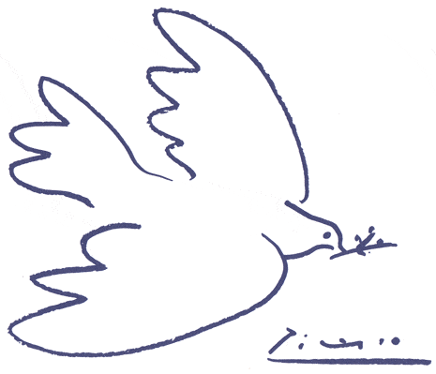

- Do you know anything about these works of art? Who were the artists? When were these paintings created?

Answer these questions about at least one of the paintings above.
- Use the KEY WORDS in your Students’ Book (page 121) to describe the painting that you have chosen.

- Now look at the paintings on page 121

Listen to the audio-file and identify the paintings: http://d.zaix.ru/iTzj.mp3

- Listen to the audio-file again and say why the people like these paintings (task 4)

Explain why you personally like this or that painting (talk about one of them)

- Write about your favorite painting

Explain why it is special for you and what problems it conveys

Don’t forget to say a few words about
- the style;
- the subject;
- the colors;
- the shapes and lines

Write your ideas here: https://forms.gle/HA4ZLB6wGn2dSADQ8

