Урок по английскому языку для 8 класса
7-12 апреля
Срок сдачи готовой работы: 12. 04.
Инструкция: задания выполнять в тетради АККУРАТНЫМ почерком, либо в учебнике, если для ответа предусмотрено место. Фото готовой работы (т.е. ВСЕ задания) высылать на эл. почту darya.elkina@mail.ru

Topic of the lesson “Extraordinary skills ”
 | материал | задание | Действия ученика
 | - | Hello students! Did you have a rest? Hope so. Let’s get started!  Before we work with the text, what martial arts are? Forgot? See Appendix 1 | Name martial arts or look at the end of this document (Appendix 1)
 | Page 88 #1,2 | Read the words, translate, write out into your copybook. Answer the questions in the tasks. | Write into copybook the answers
 | Page 88-89 #3  Page 89 #4 | - Read the text. Get the idea of the text.  - Key words. Write out, translate. Also, write out new words in the text (выделенные слова).  - Fill the gaps in the text.
 | Page 89 #6 | Match the words in copy book
 | - | Write the summary (конспект) 7-8 sentences | Send me the summary
 | Internet | Grammar . reported speech (косвенная речь)  - Что такое прямая (direct) и косвенная (reported) речь? В приложении 2 рассмотри схему перевода прямой речи в косвенную. Найди закономерности.  - См Приложение 3. Найди закономерности в изменении глаголов при переводе прямой речи в косвенную  - См видео https://interneturok.ru/lesson/english/10-11-klassy/kosvennaya-rech-i-reported-speech/reported-speech-and-reported-statements | - Выпиши закономерности в тетрадь  2)выпиши в тетрадь пару примеров
 | Internet | Some practice (основные времена)  1)present simple - приложении 4 или https://www.tolearnenglish.com/exercises/exercise-english-2/exercise-english-114272.php  2) past simle - приложении 5 или https://www.tolearnenglish.com/exercises/exercise-english-2/exercise-english-114555.php  3)future simple- приложении 6 или https://www.tolearnenglish.com/exercises/exercise-english-2/exercise-english-113883.php  4) Practice here https://www.liveworksheets.com/il87481ls and send me the results | Выбери форму тренировочных упражнений: онлайн или бумажная(не нужно делать обе ). Мне выслать ТОЛЬКО решение теста под №4)

My results (no problem) , :/ (ok), (aah…what?)
Я знаю | Martial art Skills and key words from the text
Я знаю | How to use reported speech
Я умею | Transform direct speech into the reported speech
Я не понял

Appendix 1
Martial arts (some of them)
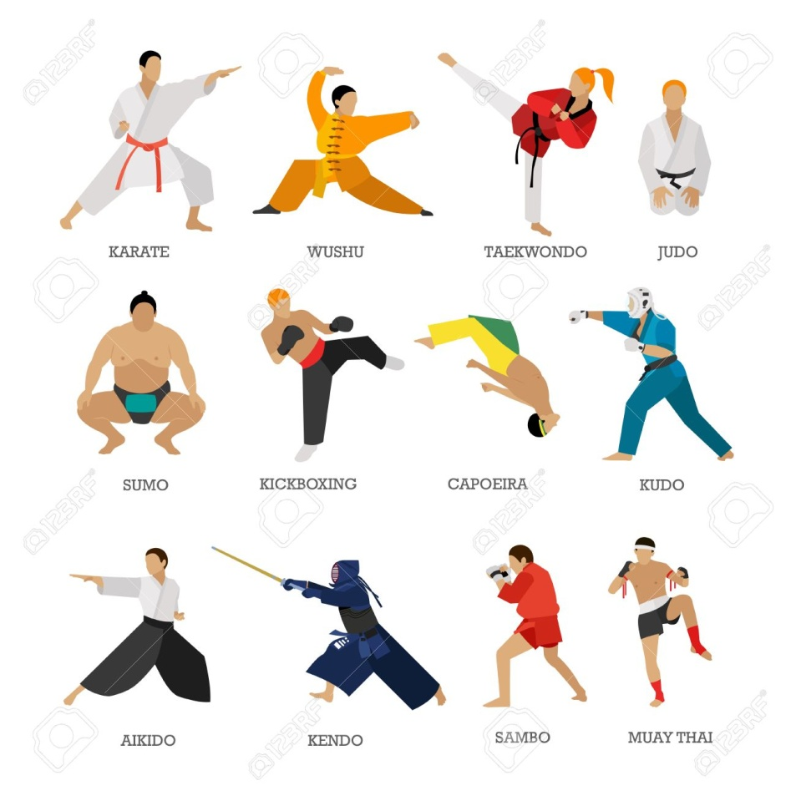
Appendix 2
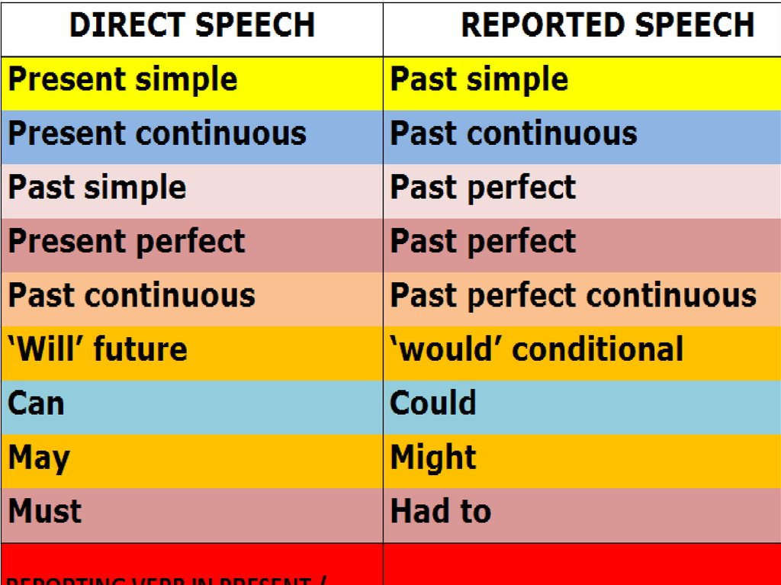
Appendix 3

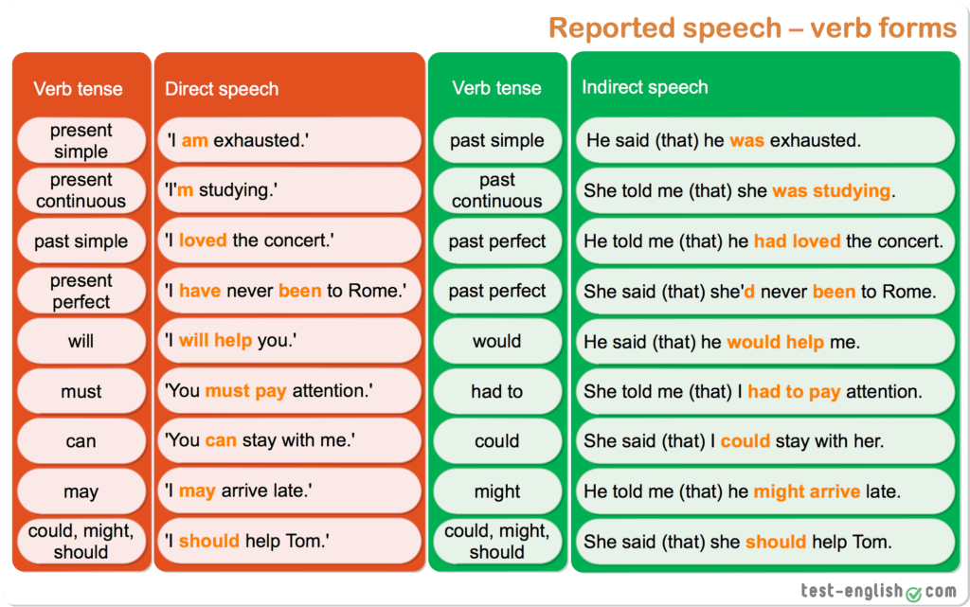

Appendix 4
present simple. reported speech
- « I am happy. » >>> Snoopy said he happy.
2. « I really like French fries. » >>> My friends swore they really French fries.
3. John : « They are doing their homework. » >>> John remembered they their homework.
4. Sandra : « We are going to the beach with my friends. » >>> Sandra told us they to the beach with her friends.
5. Peter : « I have a headache. » >>> Peter complained that he a headache.
6. « You are opening the window. » >>> I only conceded you the window.
7. « He sees strange things in his dreams. » >>> The doctor affirmed Paul strange things in his dreams.
8. Sandra : « Mum is cooking in the kitchen. » >>> Sandra recognized that her mother in the kitchen.
9. « Moriarty is guilty. » >>> Sherlock Holmes revealed to the whole world that Professor Moriarty guilty.
10. « There's an elephant inside the dining-room. » >>> My father revealed us there an elephant inside the dining-room.

Appendix 5
past simple. reported speech

- « Billy-Joe and Josephine went to new adventures. » >>> We confirmed that Billy-Joe and Josephine to new adventures.
2. A friend : « You made noise all along the party. » >>> Our friend noticed that we noise during the party.
3. « They travelled by plane to Asia. » >>> Our cousin reported us that Billy-Joe and Josephine by plane to Asia.
4. « They landed on a little deserted airport. » >>> We learned that they on a little deserted airport.
5. « Many ninjas tried to attack them. » >>> One of our friends revealed that many ninjas to attack them.
6. A witness : « They didn’t imagine the size of Josephine's teeth. » >>> A witness assured that they the size of Josephine's teeth.
7. « At this moment, we didn’t think a ninja could run so fast. » >>> Billy-Joe estimated that he a ninja could have run so fast.
8. « Billy-Joe and Josephine celebrated this event in a restaurant. » >>> A resident discovered that Billy-Joe and Josephine this event in a restaurant.
9. « They didn’t eat any ninja, of course. » >>> A scientist said that they any ninja.
10. « For some mysterious reasons, ninjas had horrible nightmares. » >>> I perceived that, for some mysterious reasons, ninjas horrible nightmares.

Appendix 6
future simple. reported speech

1. « I will buy cakes for this dinner party with friends. » >>> Josephine said (that) she cakes for this dinner party with friends.
2. « We will put our friends in the mood of that event. » >>> Billy-Joe added (that) they us in the mood of that event. »
3. « We will be uniquely welcome. » >>> I observed (that) we uniquely welcome.
4. « The doors will open to an exceptional landscape. » >>> We all noticed (that) the doors to an exceptional landscape.
5. « You will finally know some of our wonderful adventures. » >>> Billy-Joe really hoped (that) we some of their wonderful adventures.
6. « After dinner, our two friends will tell us secrets of their saga ». >>> We waited impatiently (that), after dinner, our two friends us secrets of their sagas.
7. « You won't be disappointed. » >>> Josephine added we disappointed.
8. « We will pass all those safety control systems. » >>> A friend of mine knew (that) we all those safety control systems.
9. Billy-Joe : « I will start telling the truth about Josephine and me. » >>> Billy-joe entrusted he telling the truth about Josephine and him.
10. « We will listen carefully. » >>> I knew we carefully.

