Урок по английскому языку для 8 класса
13-19 апреля
Урок 1
Срок сдачи готовой работы: 15. 04.
Инструкция: задания выполнять в тетради АККУРАТНЫМ почерком, либо в учебнике, если для ответа предусмотрено место. Фото готовой работы (т.е. ВСЕ задания) высылать на эл. почту darya.elkina@mail.ru

Topic of the lesson “reported speech/statements”
№ | материал | задание | Действия ученика
 | Page 88 text | Find examples of direct speech. Transform into the reported speech  Example: “I watched in awe as the man threw himself…” he said that he had watched in awe as the man had thrown himself..”  Use Appendix 1 for help | Write 5 examples
2. |  | https://www.liveworksheets.com/worksheets/en/English_as_a_Second_Language_(ESL)/Reported_speech/Reported_Speech_ap15501bo | Send me

Appendix 1
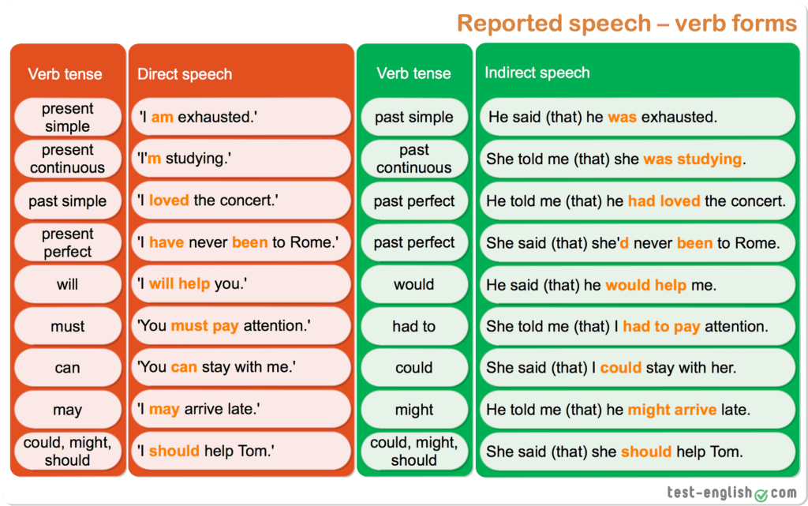

Урок 2
Срок сдачи готовой работы: 17. 04.
Инструкция: задания выполнять в тетради АККУРАТНЫМ почерком, либо в учебнике, если для ответа предусмотрено место. Фото готовой работы (т.е. ВСЕ задания) высылать на эл. почту darya.elkina@mail.ru

Topic of the lesson “the way we learn”
№ | материал | задание | Действия ученика
 | Page 90 #2a | Key-words “Technology in education” | Write out into copybook, translate
2. | Page 90 #3 | Key-words +read the text | Read the text,
3. | Page 90 #4a | Find proofs in the text | Send me the results

Урок 3
Срок сдачи готовой работы: 19. 04.
Инструкция: задания выполнять в тетради АККУРАТНЫМ почерком, либо в учебнике, если для ответа предусмотрено место. Фото готовой работы (т.е. ВСЕ задания) высылать на эл. почту darya.elkina@mail.ru

Topic of the lesson “reported speech/ commands and questions”
№ | материал | задание | Действия ученика
 | internet | Видео урок https://interneturok.ru/lesson/english/7-8-klassy/kosvennaya-rech/reporting-verbs-questions-orders-and-requests
2. | Appendix 1 общие вопросы | “Do you like?” - she asked if I liked (present past)  “Did you like?” – she asked if I had liked (past past perfect)  “Will you go?” – she asked if I would go (will would) | Выпиши закономерности
3. | Appendix 2 специальные вопросы | “What do you like?” ---- she asked what I liked (present past)  “Why did you like it?” ---- she asked why I had liked it (past past perfect)  “Where will you go?”--- she asked where I would go (will would) | Выпиши закономерности
4 | Appendix 3 приказы и команды | “Eat soup.” – she told me o eat soup.  “don’t eat sweets” – she ordered not to eat sweets. | Выпиши закономерности
5 | Internet | https://www.liveworksheets.com/worksheets/en/English_as_a_Second_Language_(ESL)/Reported_speech/Reported_speech_hc138ye | Send me results

Appendix 1
Вопросы в косвенной речи

Общие вопросы в косвенной речи(требуют ответа да/нет).
Прочитайте примеры, обращая внимание на структуру косвенных вопросов:
Direct question: “Did you turn off the TV?”
Reported question: She asked if / whether I had turned off the TV.
Direct question: “Are you busy now?”
Reported question: He asked her if/whether she was busy then.

Упражнение

Составьте косвенные вопросы из данных слов.

- She asked /they /if /her friend/ had seen.
- whether /with them /he would go /they wanted to know.
- then/ they were playing football/ if/ Jeremy wanted to know.
- she was wearing/ if /he asked/ that ring /that night.
- he left/ for Moscow / whether/ we wanted to know.
- he could eat / if/ that cake/ Mike asked.

Правильные ответы:
- She asked if they had seen her friend.
- They wanted to know whether he would go with them.
- Jeremy wanted to know if they were playing football then.
- He asked if she was wearing that ring that night.
- We wanted to know whether he left for Moscow.
- Mike asked if he could eat that cake.

Appendix 2
Вопросы в косвенной речи

Специальные вопросы в косвенной речи (требуют полного ответа)
Прочитайте примеры, обращая внимание на структуру специальных косвенных вопросов:

Direct question: “What time does the film begin?”
Reported question: He asked what time the film began.
Direct question: “Where did you go to school?”
Reported question: She asked me where I had gone to school.
Direct question: “Why are you crying?”
Reported question: He asked her why she was crying.

Упражнение

Исправьте ошибки в предложениях.
- 1. My friend asked me when had Mary talked to Kevin.
- The man asked me if the post office was.
- She asked me when got up Lucy had the day before.
- My friend wanted to know when was I going swimming.
- She asked her boyfriend which dress did he like best.
- The mother asked her daughter she had been where.
- George asked where did bears live.
Правильные ответы.
- My friend asked me when Mary had talked to Kevin.
- The man asked me where the post office was.
- She asked me when Lucy had got up the day before.
- My friend wanted to know when I was going swimming.
- She asked her boyfriend which dress he liked best.
- The mother asked her daughter where she had been.
- George asked where bears lived.

Appendix 3
Приказы/команды

Приказы в косвенной речи
Обычно используют глагол tell для передачи приказов в косвенной речи, и после него используется инфинитив глагола.
tell + (pro)noun + to + infinitive

The teacher told Mike to read the text.
The mother told her child not to run.

Отрицательные команды
Обратите внимание! Частичка not стоит перед инфинитивом.

The mother told her child not to run.

Прочитайте и проанализируйте примеры, обращая внимание на изменения при образовании приказов в косвенной речи.

Direct order: Mother said, "Eat your food now!"
Reported order: Mother told her son to eat his food right then.
Direct order: The teacher said, "You must finish this exercise before a break."
Reported order: The teacher told me to finish that exercise before a break.

Вместо глагола tell можно также использовать следующие глаголы сообщения
order – приказывать
command – командовать
instruct – наставлять, давать указания

The teacher said, “Stop talking.”
The teacher ordered the pupils to stop talking.

