Урок по английскому языку для 9 класса
12-17 мая
Урок 1
Срок сдачи готовой работы: 14.05
Инструкция: задания выполнять в тетради АККУРАТНЫМ почерком, либо в учебнике, если для ответа предусмотрено место. Фото готовой работы (т.е. ВСЕ задания) высылать на эл. почту darya.elkina@mail.ru
Topic of the lesson “ reported speech and questions”
№ | материал | задание | Действия ученика
 | Appendix 1 | Refresh tne basic rules
 | Appendix 2 | Read the joke, find the direct speech sentences and transform them into the reported ones.  Use these verbs: advise, remind, offer, accuse, insist, persuade, etc | Send me back

Appendix 1
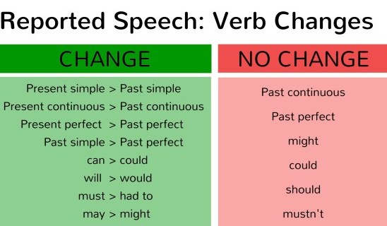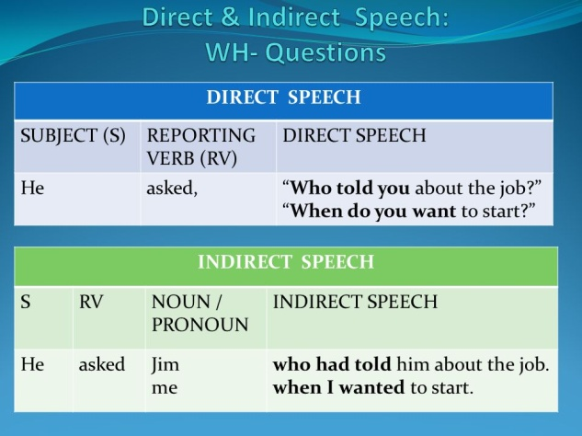
Appendix 2
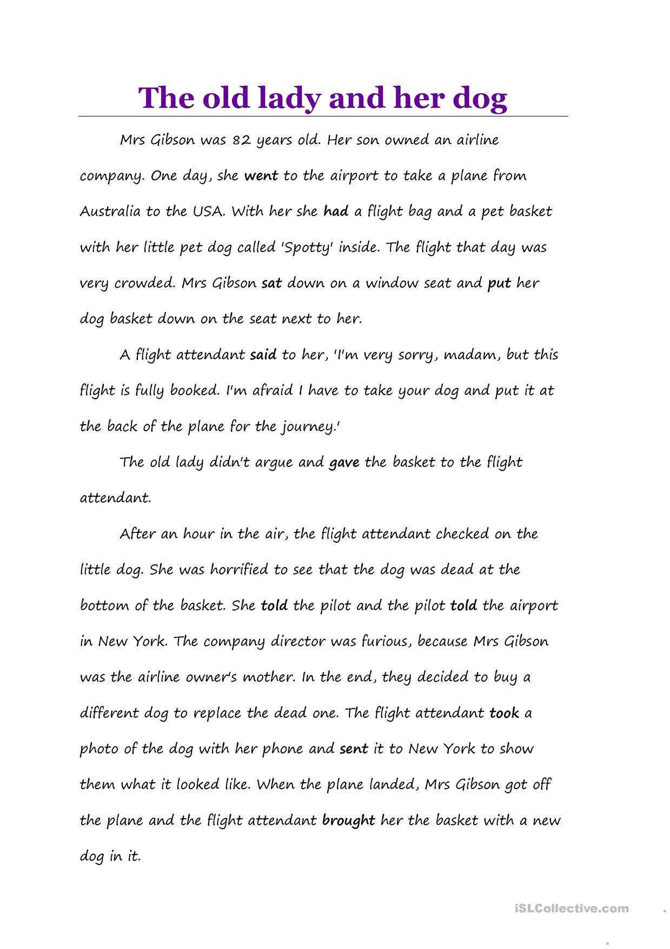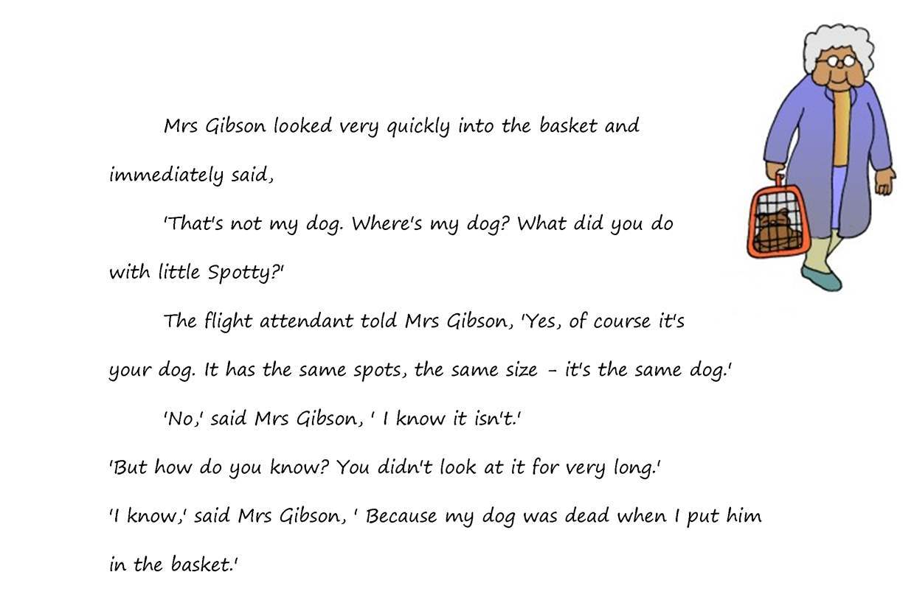
Урок 2
Срок сдачи готовой работы: 16.05
Инструкция: задания выполнять в тетради АККУРАТНЫМ почерком, либо в учебнике, если для ответа предусмотрено место. Фото готовой работы (т.е. ВСЕ задания) высылать на эл. почту darya.elkina@mail.ru
Topic of the lesson “Reading”

Robot teachers
If you think of the jobs robots could never do, you would probably put doctors and teachers at the top of the list. It's easy to imagine robot cleaners and factory workers, but some jobs need human connection and creativity. But are we underestimating what robots can do? In some cases, they already perform better than doctors at diagnosing illness. Also, some patients might feel more comfortable sharing personal information with a machine than a person. Could there be a place for robots in education after all?
British education expert Anthony Seldon thinks so. And he even has a date for the robot takeover of the classroom: 2027. He predicts robots will do the main job of transferring information and teachers will be like assistants. Intelligent robots will read students' faces, movements and maybe even brain signals. Then they will adapt the information to each student. It's not a popular opinion and it's unlikely robots will ever have empathy and the ability to really connect with humans like another human can.
One thing is certain, though. A robot teacher is better than no teacher at all. In some parts of the world, there aren't enough teachers and 9–16 per cent of children under the age of 14 don't go to school. That problem could be partly solved by robots because they can teach anywhere and won't get stressed, or tired, or move somewhere for an easier, higher-paid job.
Those negative aspects of teaching are something everyone agrees on. Teachers all over the world are leaving because it is a difficult job and they feel overworked. Perhaps the question is not 'Will robots replace teachers?' but 'How can robots help teachers?' Office workers can use software to do things like organize and answer emails, arrange meetings and update calendars. Teachers waste a lot of time doing non-teaching work, including more than 11 hours a week marking homework. If robots could cut the time teachers spend marking homework and writing reports, teachers would have more time and energy for the parts of the job humans do best.
Are the sentences true or false? Highlight the proofs in the text
1. Most jobs seem as if they can be done by robots or computers.

2. Robots are always better at diagnosing illnesses than doctors.

3. Many experts agree robots will replace teachers by 2027.

4. One advantage of robot teachers is that they don't need to rest.

5. Robot assistants could help teachers by marking homework and writing reports.

6. Some teachers use robots to reduce their time answering emails and marking homework.

Урок 3-4

Срок сдачи готовой работы: 17.05
Инструкция: задания выполнять в тетради АККУРАТНЫМ почерком, либо в учебнике, если для ответа предусмотрено место. Фото готовой работы (т.е. ВСЕ задания) высылать на эл. почту darya.elkina@mail.ru
Topic of the lesson “Used to/ be used to Ving/ get used to ”
№ | материал | задание | Действия ученика
1 |  | Used to=раньше делал, теперь нет  Would = раньше делал, теперь нет (только глаголы-действия)  be used to Ving =привык делать что-то/к чему -то  get used to =привыкаю делать что-то/к чему-то
2 | Used to/ be used to Ving/ get used to | https://www.liveworksheets.com/worksheets/en/English_as_a_Second_Language_(ESL)/Grammar/Be-Get_used_to_-_Used_to_-_Would_kl141480rk | Send me

